WEEK 3 - ENTITY FRAMEWORK HOL

The source code is provided in repository under each week laboratories.  
  
  
LAB 1:  
 **Understanding ORM with a Retail Inventory System**

The content is in [README.md](http://readme.md) file  
LAB 2:

**Setting Up the Database Context for a Retail Store**  
OUTPUT:  
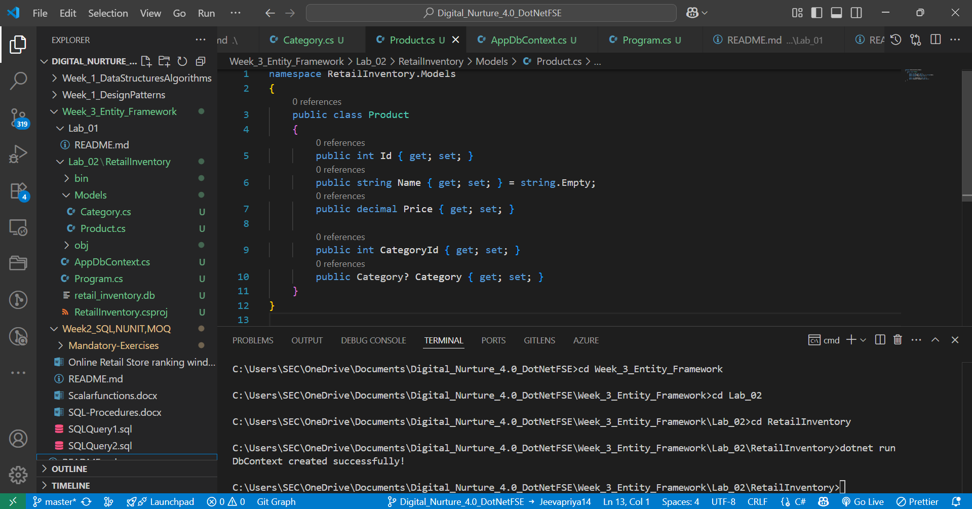



**LAB 3:**

**Using EF Core CLI to Create and Apply Migrations**

**OUTPUT:**

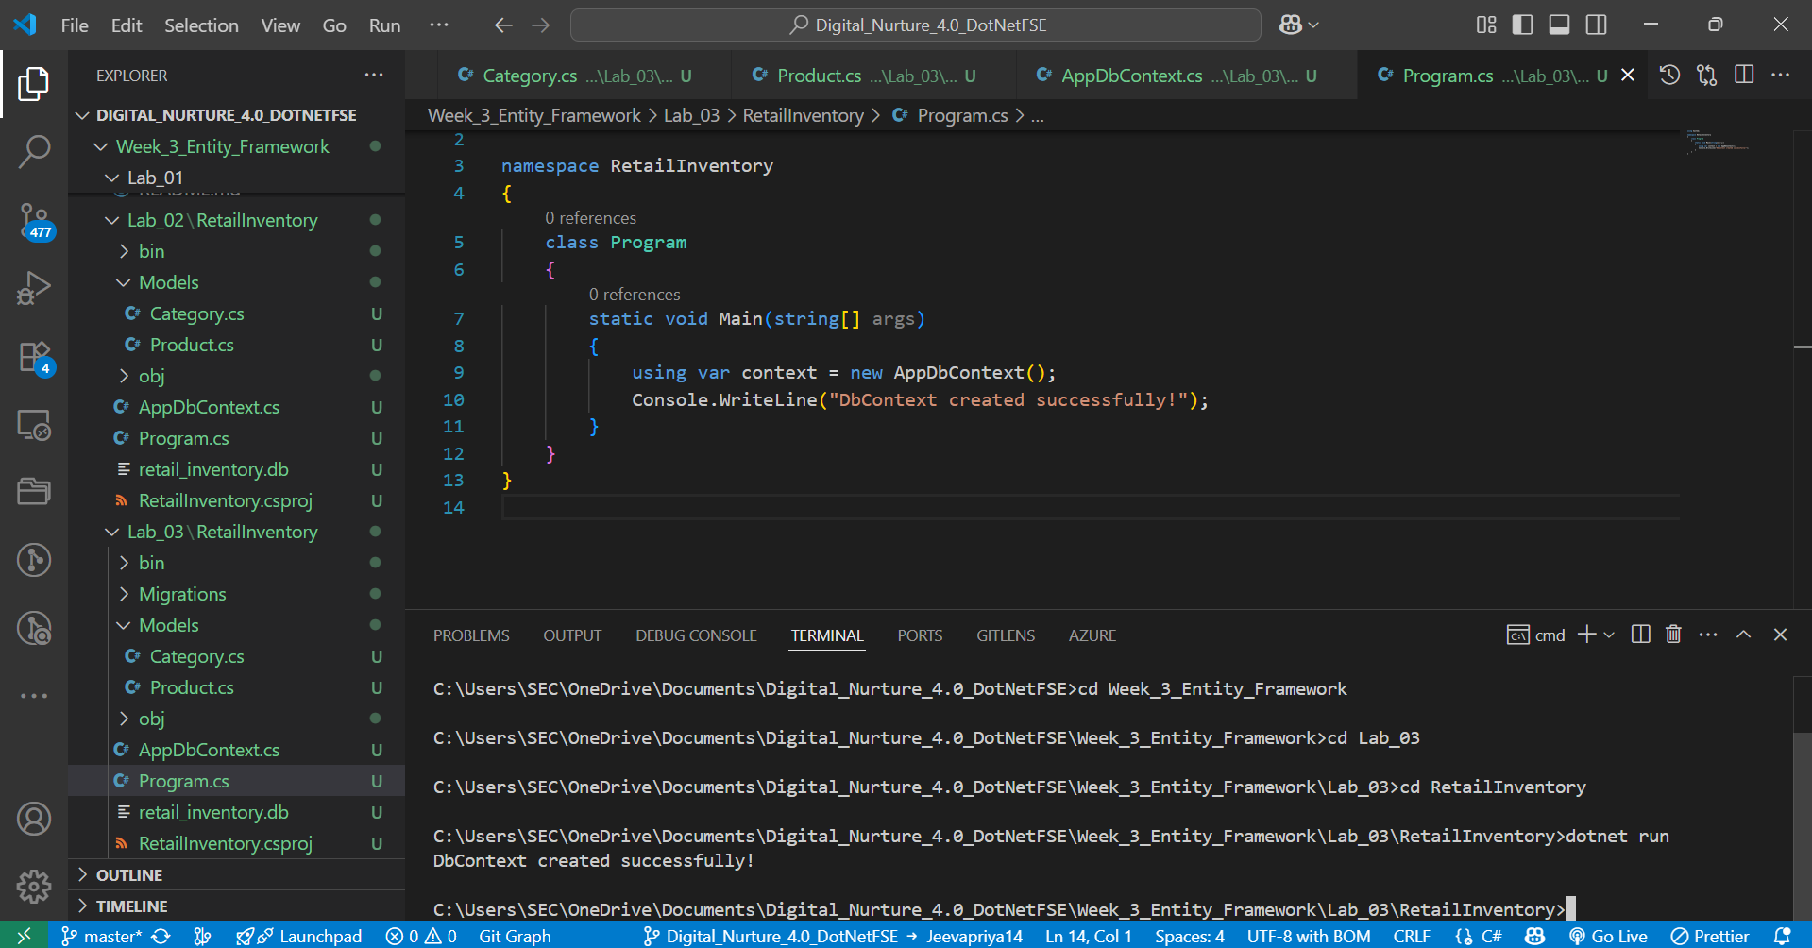



**Lab 4: Inserting Initial Data with EF Core**

**OUTPUT:**

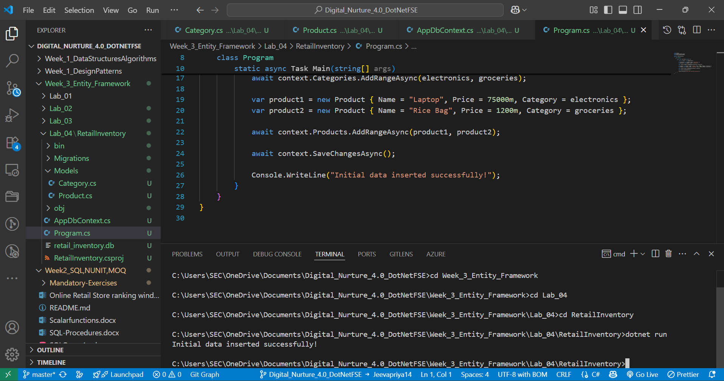



**Lab 5: Retrieving Data from the Database**

**OUTPUT:  
  
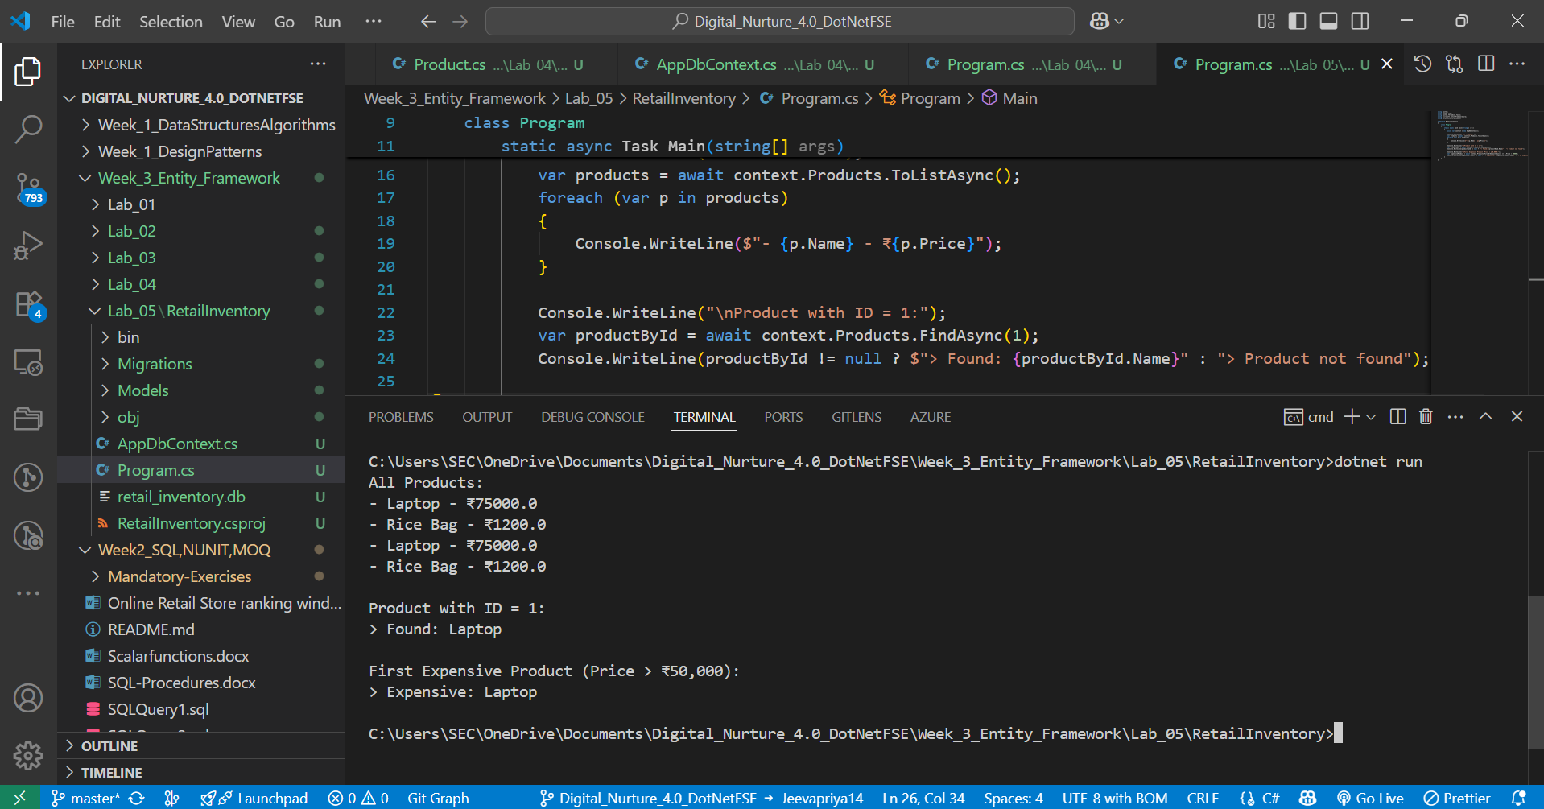  
  
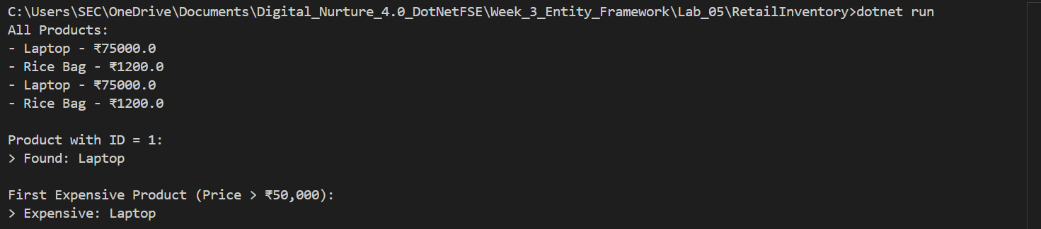**

**LAB 06: Updating and Deleting Records**

**Updating and Deleting Records**

**OUTPUT:**

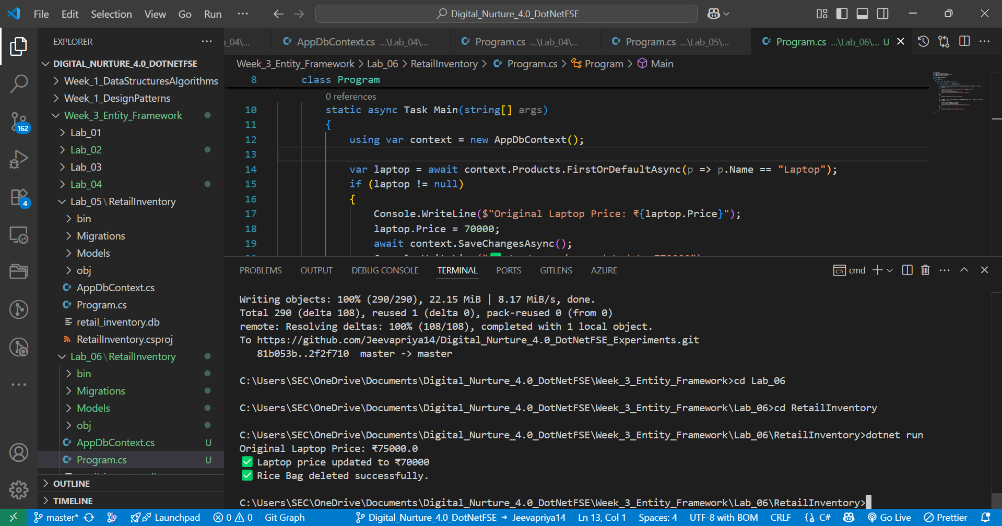



**Lab 7: Writing Queries with LINQ**

**OUTPUT:  
  
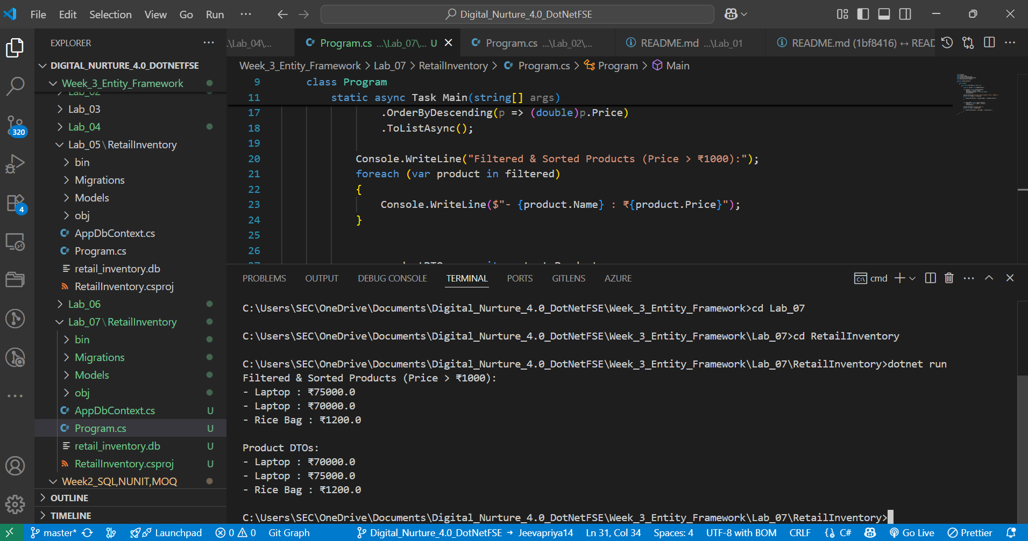**

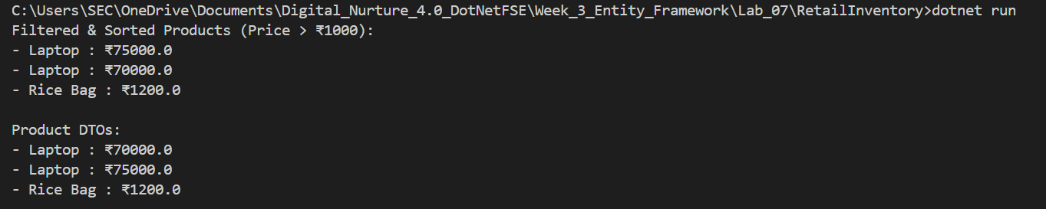

**Lab 8: Managing Migrations and Schema Changes**

**OUTPUT:  
  
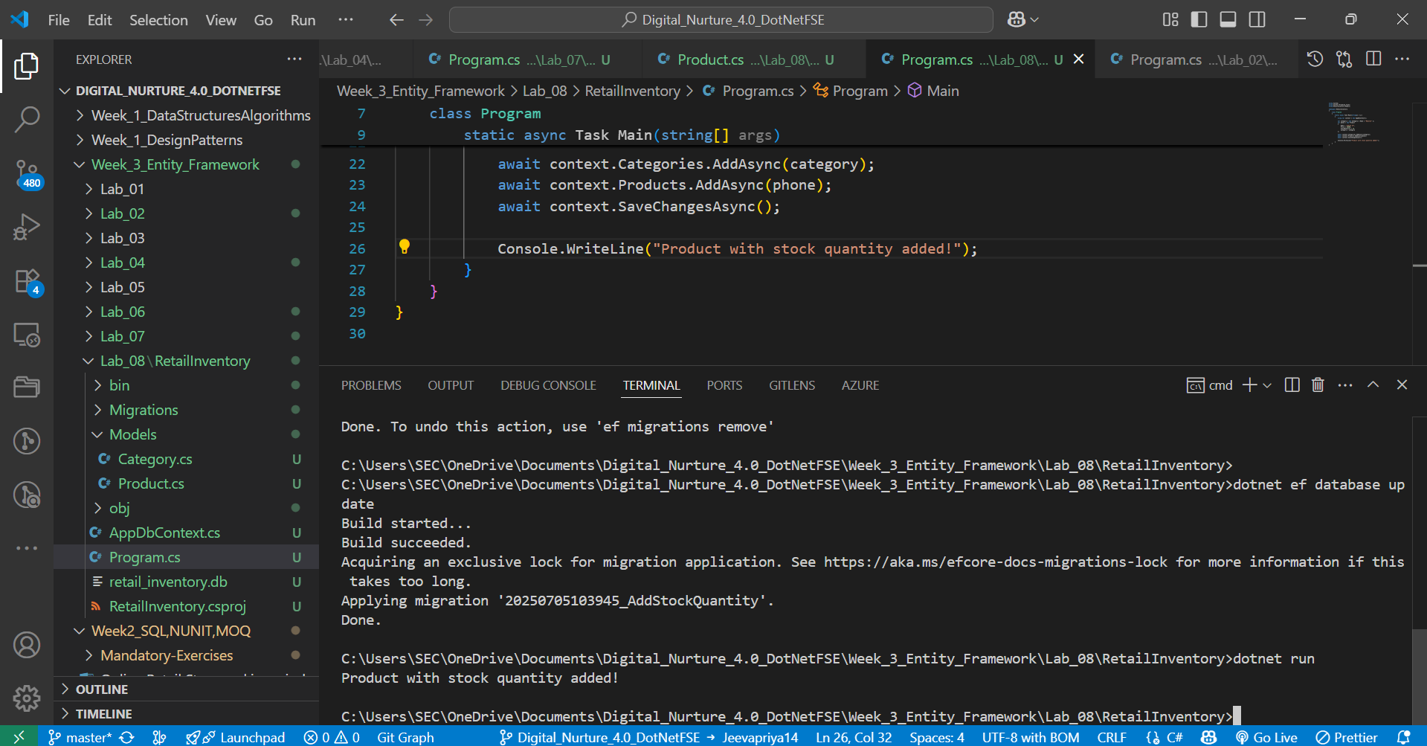  
  
**

**Lab 9: Seeding Data During Migrations  
  
OUTPUT:**

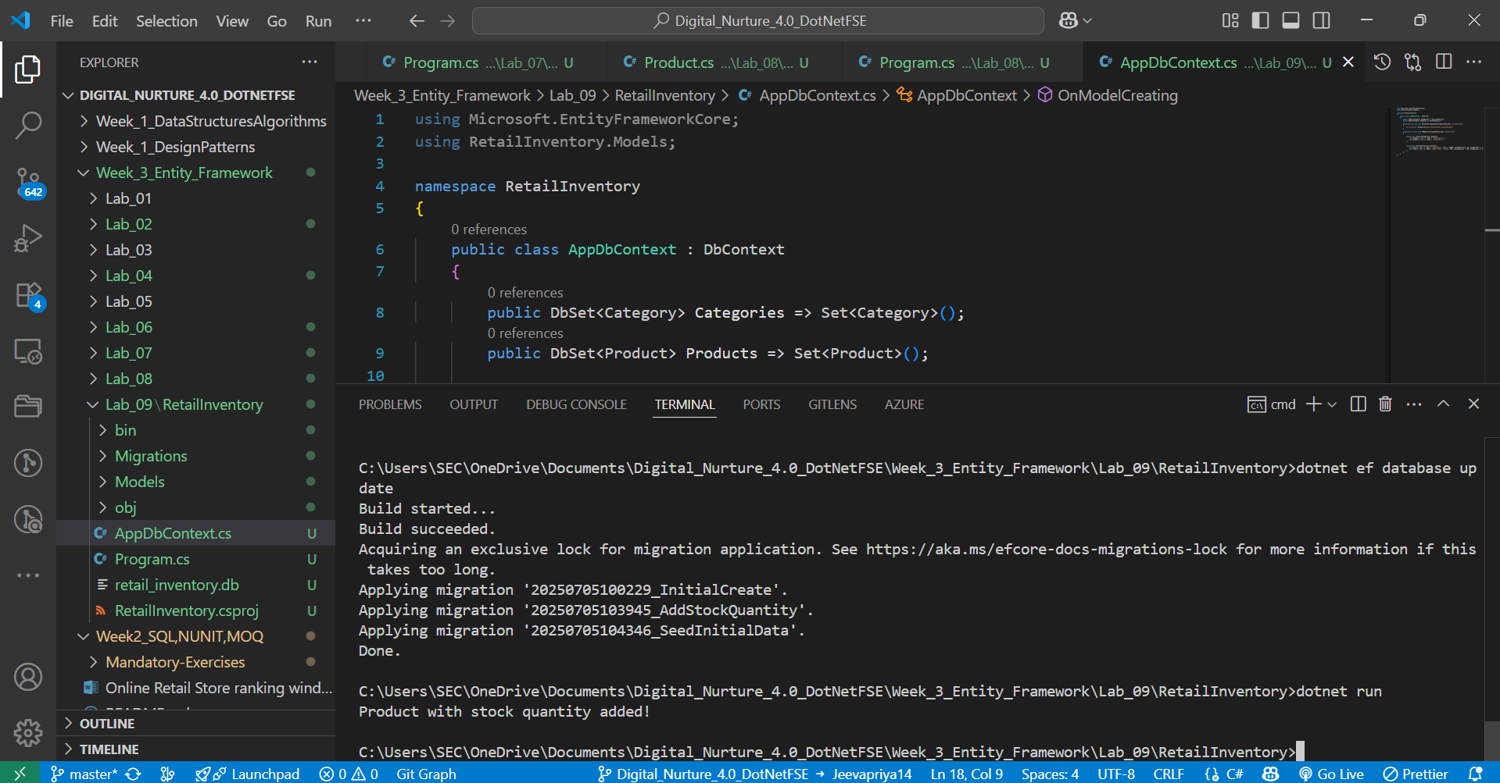



**Lab 10: Eager, Lazy, and Explicit Loading**

**OUTPUT:  
  
  
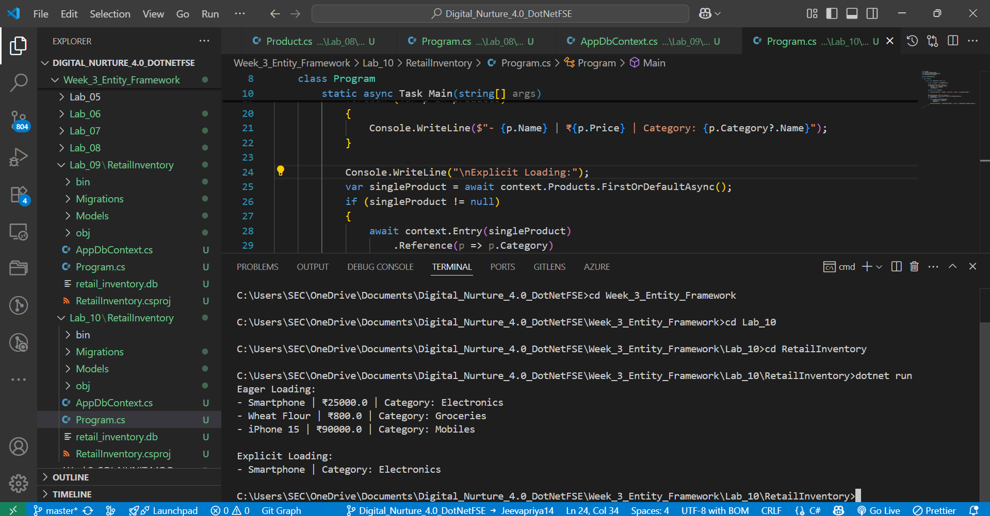**

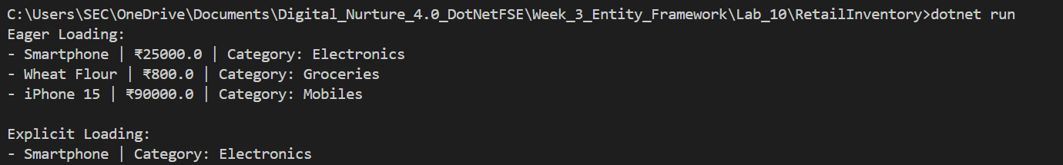

**Lab 11: Configuring One-to-One and Many-to-Many Relationships**

**OUTPUT:  
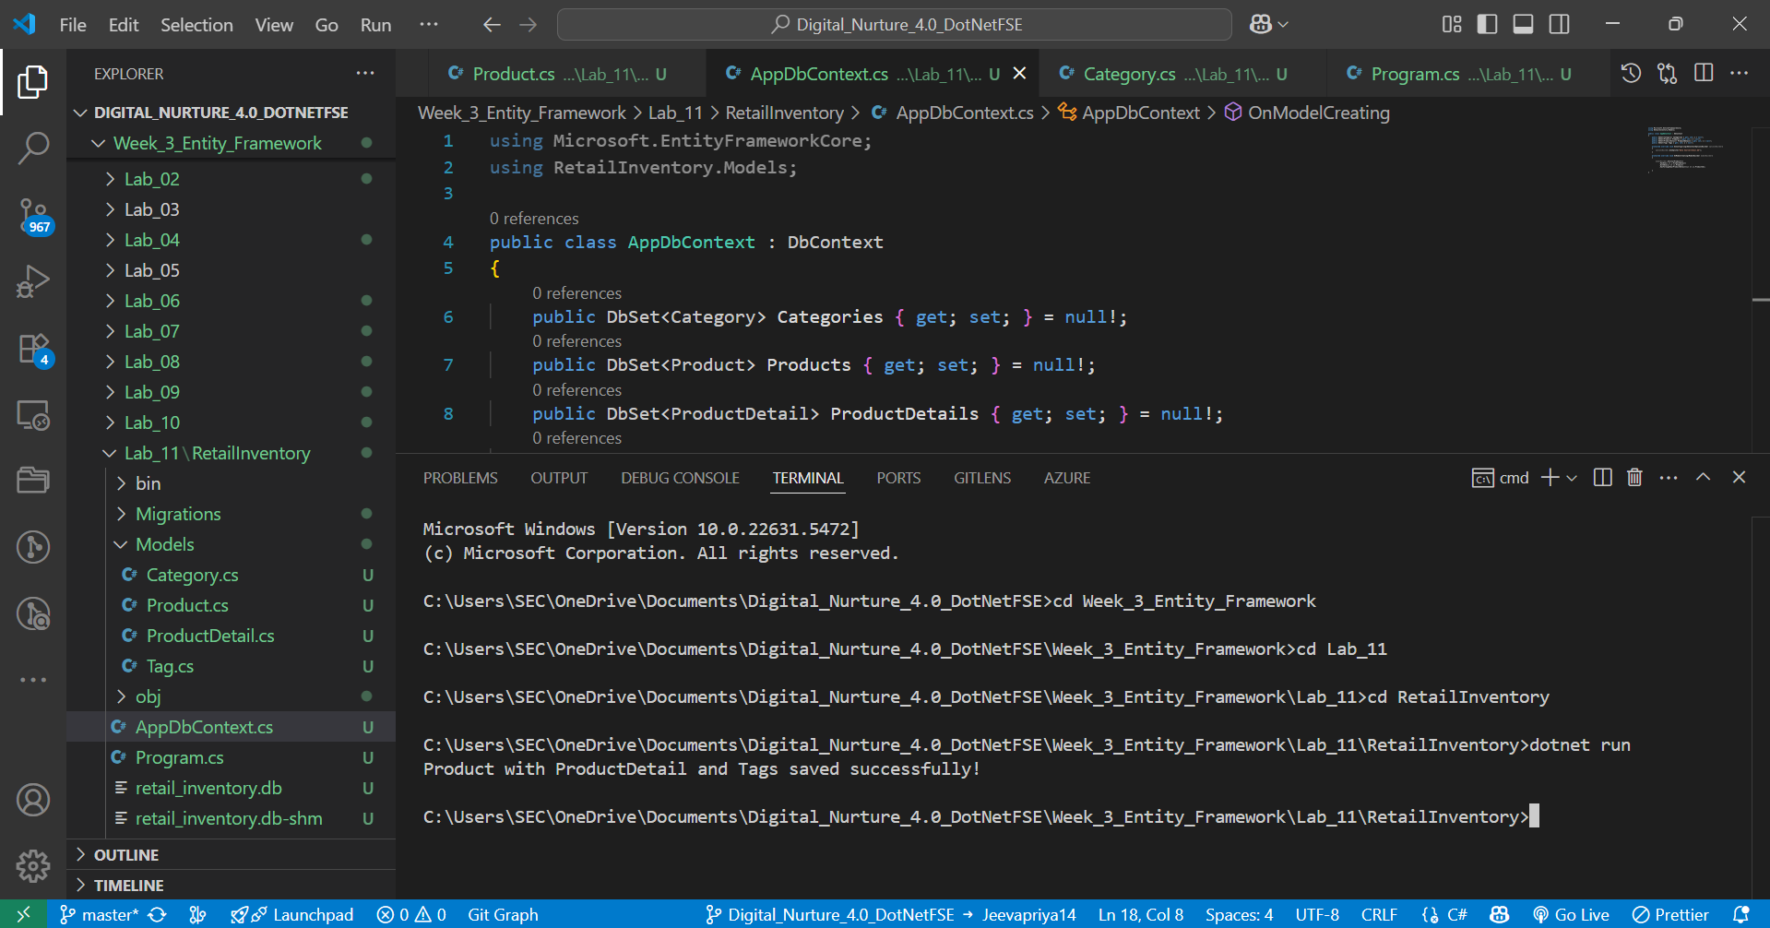  
**

**Lab 12: Navigating Circular References**

**Output:  
  
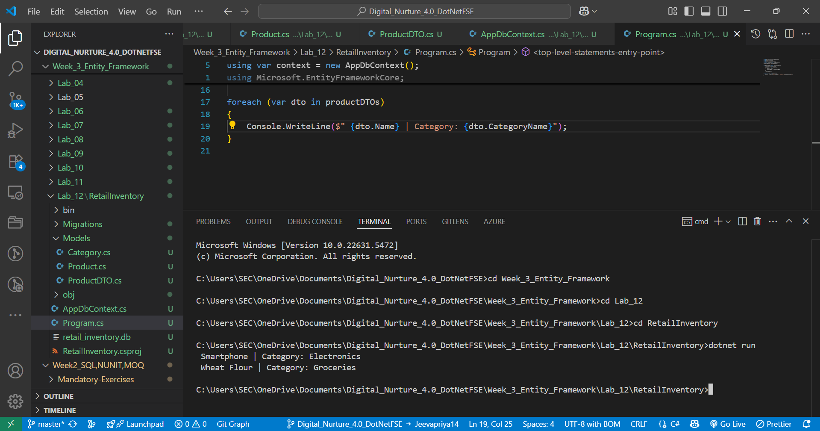  
  
  
  
Lab 13: Query Caching and Tracking Behavior**

**OUTPUT:  
  
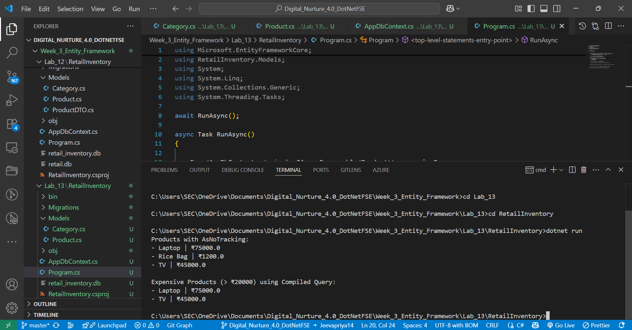  
  
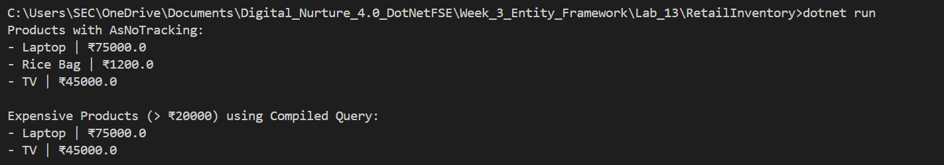  
  
Lab 14: Batch Processing and Bulk Operations  
  
OUTPUT:  
  
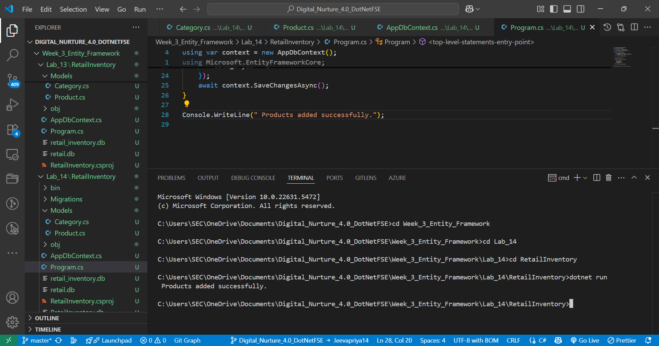  
  
  
  
Lab 15: Handling Concurrency with RowVersion**

**OUTPUT:  
  
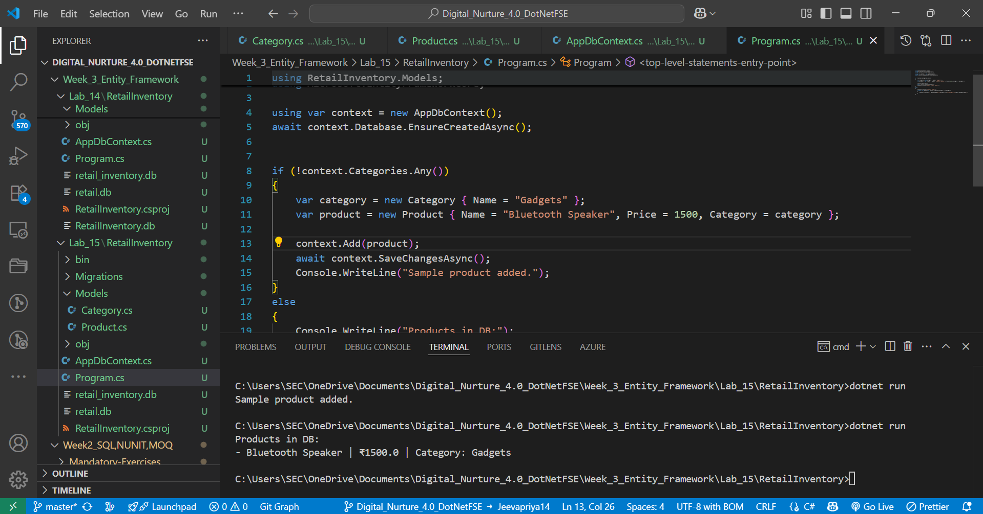  
  
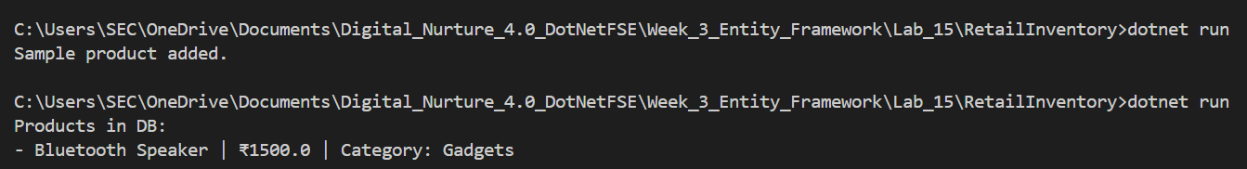**

RESULT:  
  
 Thus, All the laboratory exercises are correct and executed successfully.